eHealth BE Compliance for Log360

**Tagline** – Secure Belgian healthcare data and automate eHealth compliance with Log360
**Overview**
The eHealth BE Compliance extension for Log360 helps Belgian healthcare organizations maintain compliance with eHealth standards and data security requirements. By integrating this extension, IT and security teams gain deep visibility into their healthcare data protection posture.
Log360 continuously collects and correlates log data from Active Directory, Windows, Unix/Linux, Microsoft 365, cloud platforms, and network devices, mapping events directly to eHealth BE controls. Security teams can track compliance status in real time, investigate incidents quickly, and generate audit-ready reports with a single click.

**Key Features:**
- Generate comprehensive audit-reports mapped to each of the eHealth BE healthcare data protection controls.
- Securely stores and archives logs for customizable retention periods meeting all eHealth data preservation requirements.
- Offers pre-built and customizable reports for healthcare compliance with interactive dashboards for monitoring.
- Export reports in PDF and CSV format for auditors, management, or regulatory submissions.

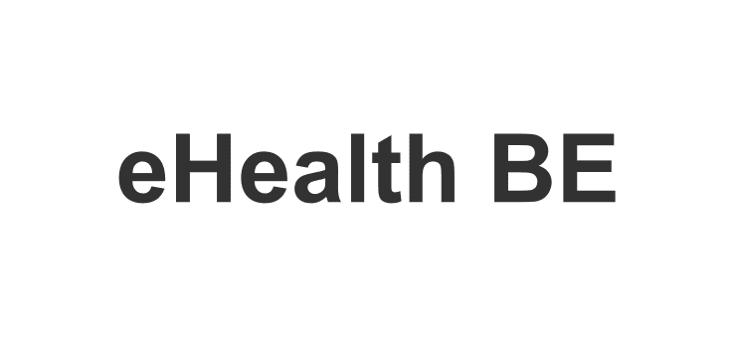
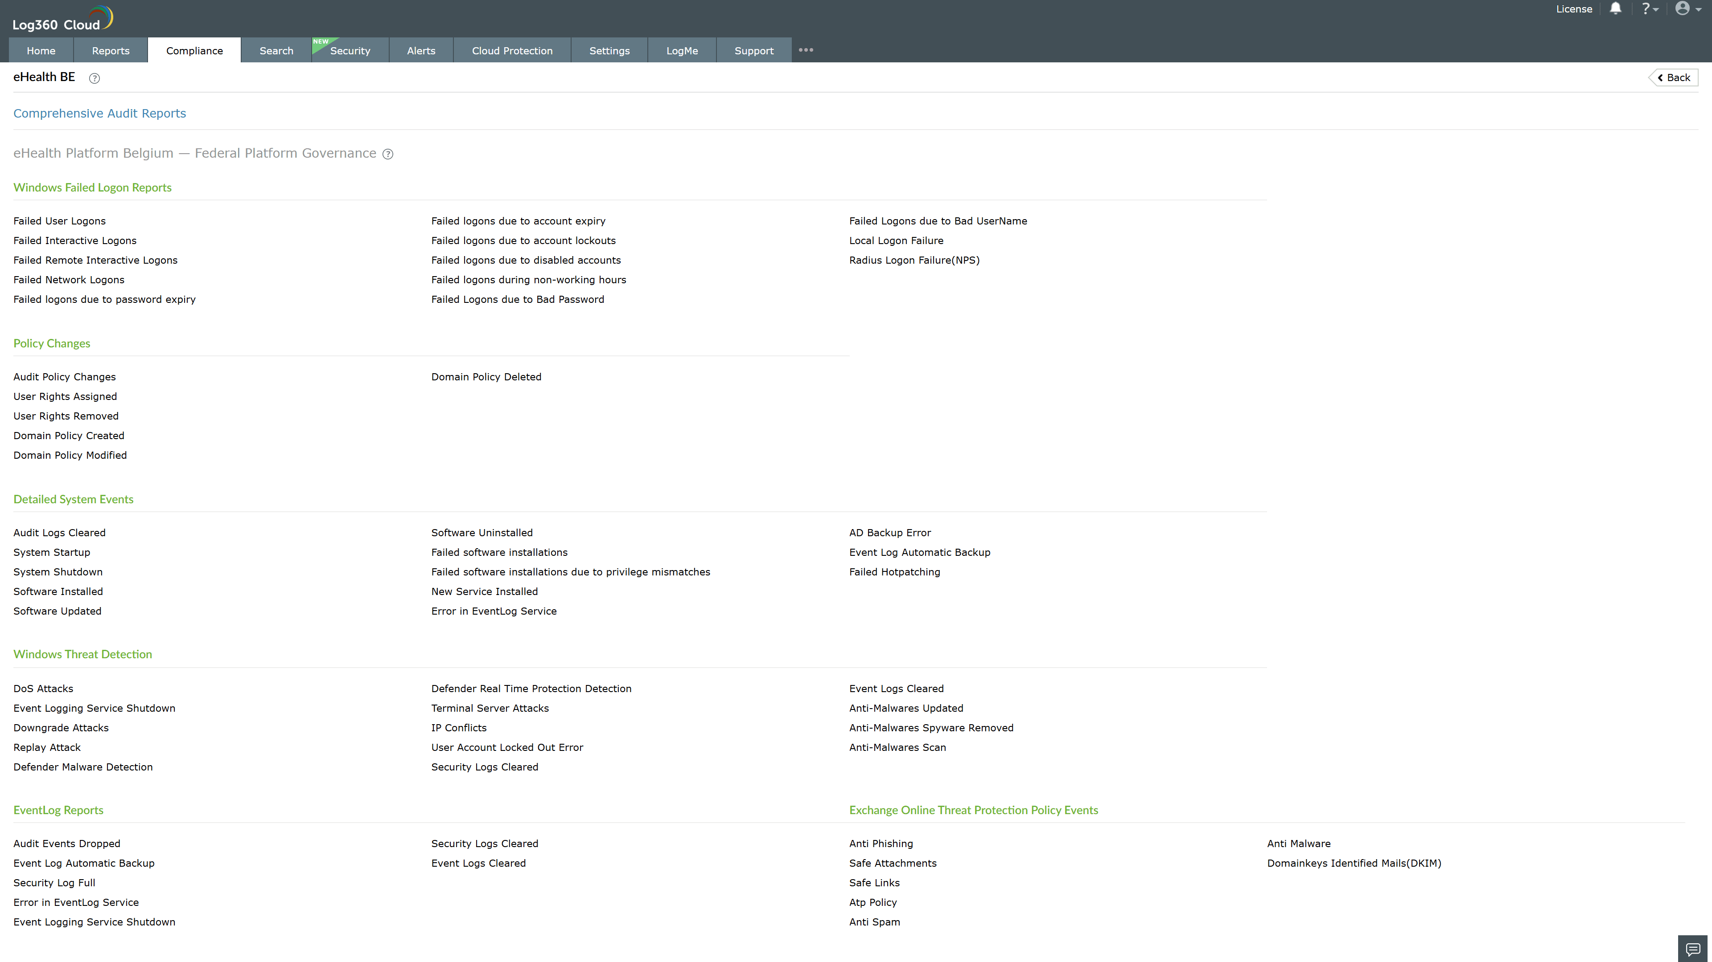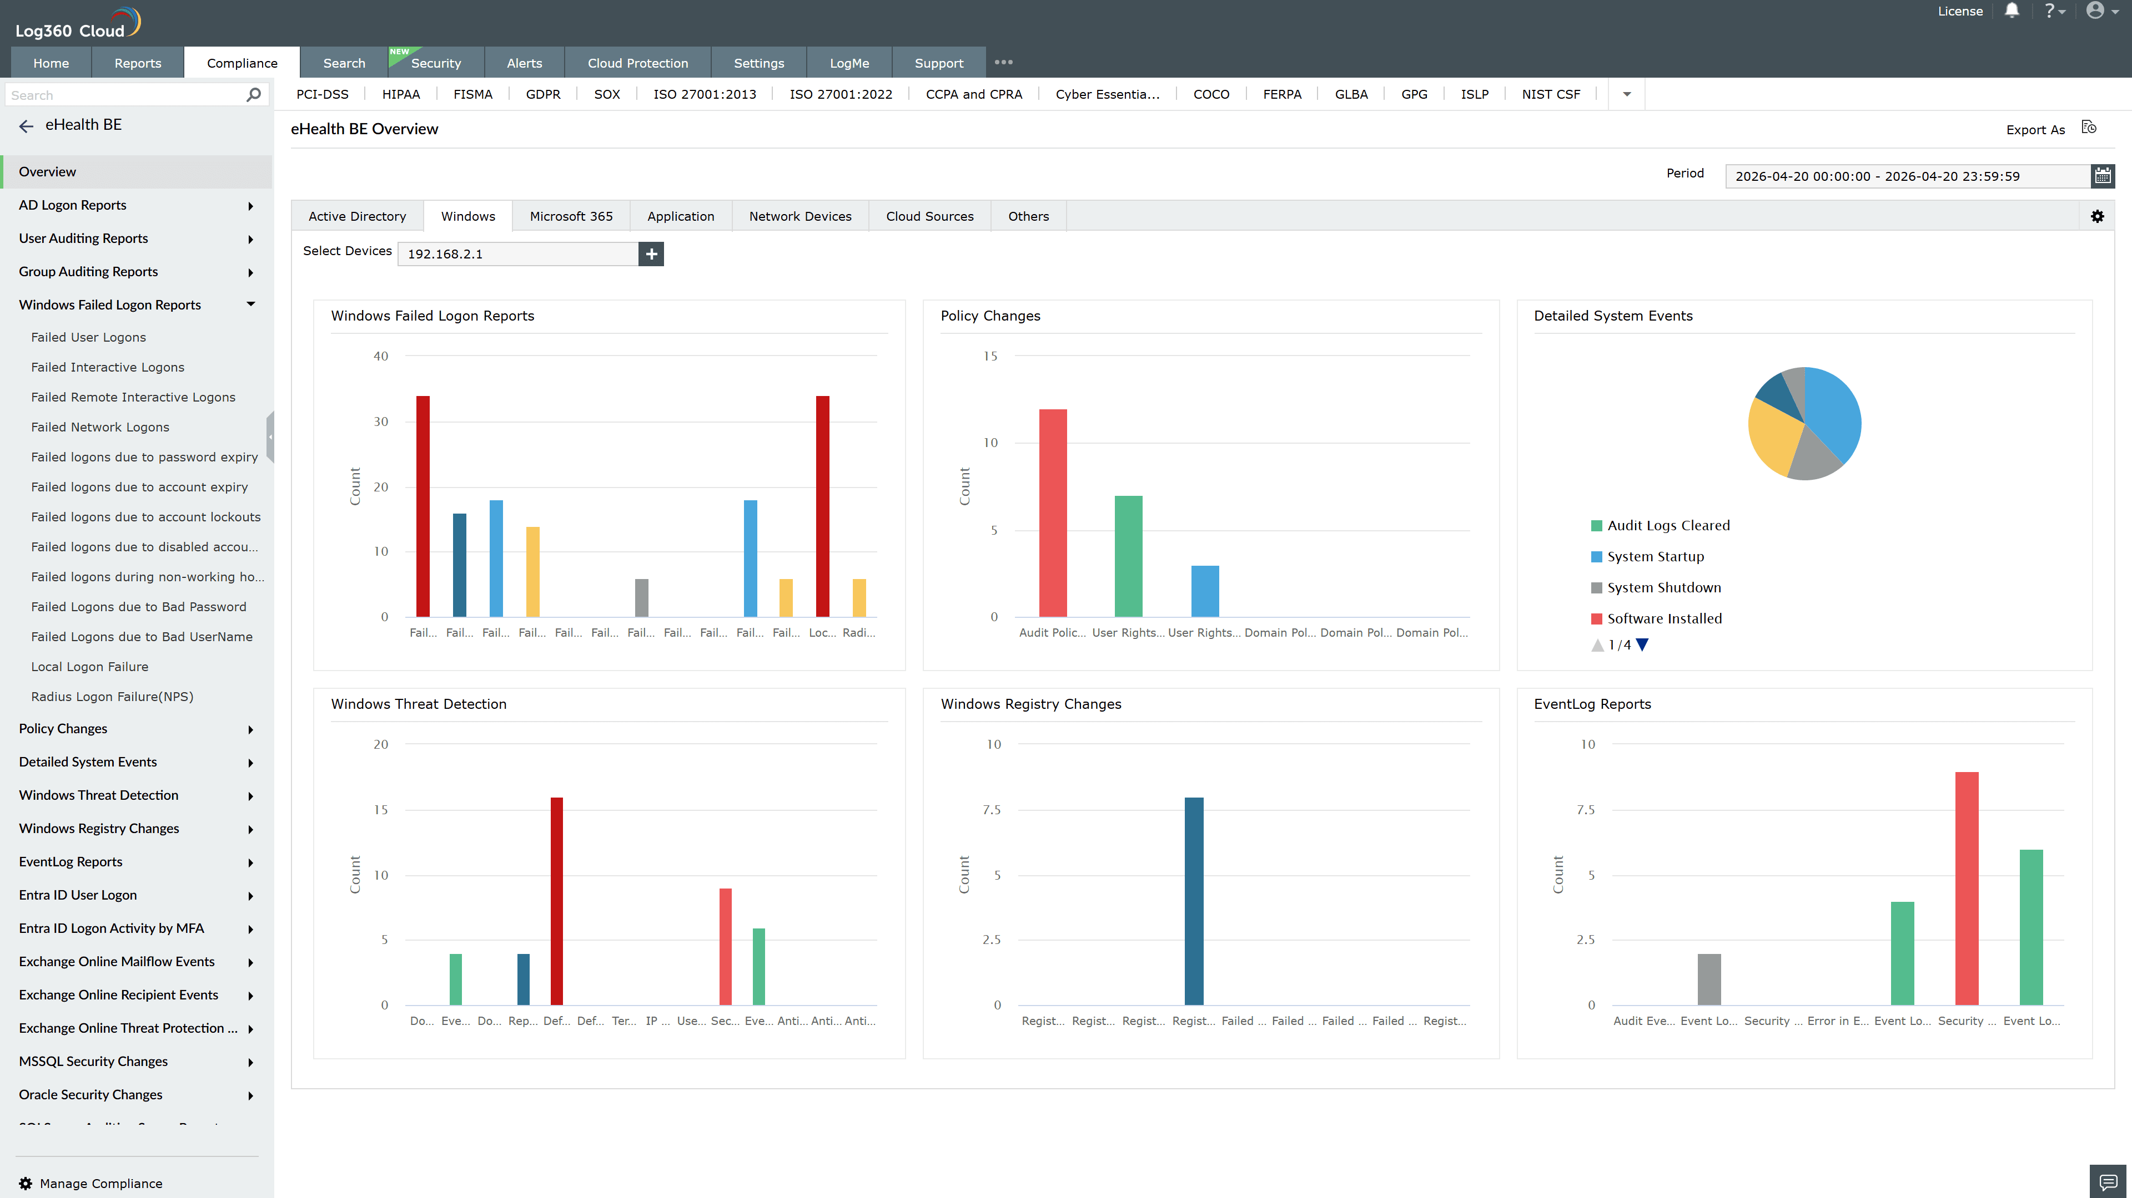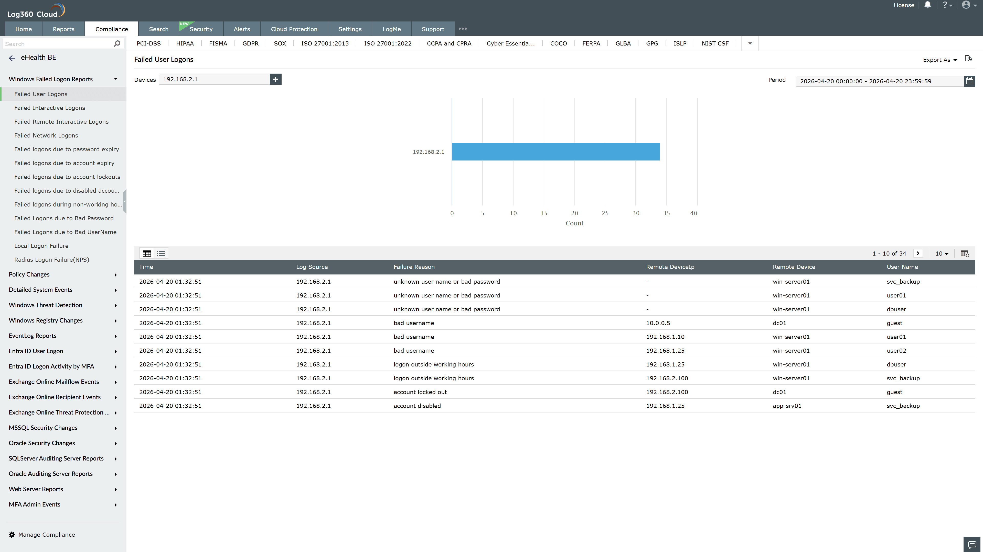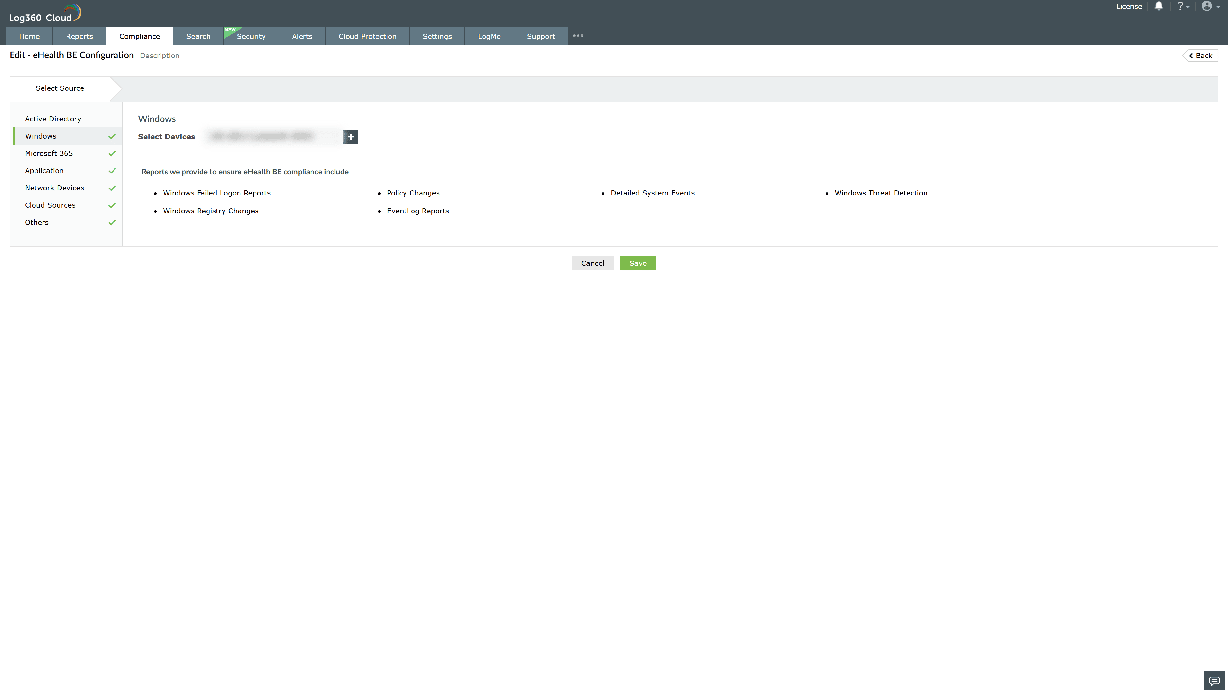
Valid Submission : Yes
Supported Editions : Free, Basic, Standard, Professional, MSSP
Help Document : https://www.manageengine.com/log-management/help/integrations/compliance-extensions.html
Help Video : Not provided
Tags : Log360, Compliance, Privacy monitoring, Data privacy, Regulatory compliance
Supported DCs : US, IN, JP, CA, AU, UK and EU
Privacy Policy:
Terms of Service:
Release Notes:
Predefined reports for the eHealth BE Compliance.

